Shrimp Task Force Meeting
Wednesday, April 20, 2022, 10:00am
Terrebonne Parish Main Library
151 Library Dr., Houma, LA 70360

I. Pledge of Allegiance
II. Roll Call
Voting Members Present:
Rodney Olander
Acy Cooper, Jr.
Lance Nacio
Jeff Drury, III
Alan Gibson
Andrew Blanchard
Randy Pearce
Chalin Delaune

Voting Members Absent:
Ronald Anderson, Jr.
Phillip Tran
Kristen Baumer

Non-Voting Members Present:
Peyton Cagle
Davis Madere in for Bryan Marie
Jack Isaacs
Gene Cavalier

Non-Voting Members Absent:
Adam Eitmann
Justin Gremillion

III. Acy Cooper motioned to approve the February 16, 2022 meeting minutes, 2nd by Rodney Olander. Motion carries.

IV. Rodney Olander motioned to move item E. under New Business to item A., 2nd by Acy Cooper. Motion carries.

Lance Nacio motioned to add an item under New Business, To Discuss the Possibility of an Early Opening of White Shrimp Season on the Inside- STF, 2nd by Acy Cooper. Motion carries.
Acy Cooper motioned to add an item under New Business, To Discuss TEDs and Debris in Grand Isle- STF, 2nd by Lance Nacio. Motion carries.
Rodney Olander motioned to add an item under New Business, To Hear an Update on the 2019 Fisheries Flood Disaster Funding- STF, 2nd by Acy Cooper. Motion carries.
Lance Nacio motioned to approve the April 20, 2022 STF meeting agenda as amended, 2nd by Rodney Olander. Motion carries.
V. Financial Report
Remaining Fund Balance- $689,108
Remaining Budget Balance- $47,126

Alan Gibson motioned to accept the financial report as presented, 2nd by Acy Cooper. Motion carries.

VI. The task force received an update on the Federal Shrimp Permit Report

VII. New Business

- Melanie Tullier provided an update on LDAF’s Louisiana Seafood Processors Pandemic Response and Safety Program
Eligible beneficiaries- Louisiana residents possessing any of the following LA Dept. of Wildlife and Fisheries licenses in 2020 and/or 2021:
- Residential Wholesale/Retail Seafood License- business
- Residential Wholesale/Retail Seafood License- vehicle
- Residential Seafood Retail/Dealer License- business
- Residential Seafood Retail/Dealer License- vehicle
- Residential Vessel License

Will begin taking applications from July 1- 29, 2022 (all applications must be delivered or post-marked no later than July 29, 2022)
Awarded amounts- Up to $100,000 based on approval and availability of funds. If, after the close of the application period, the total request for funds exceeds the program allocation, the state will use a pro-rata allocation process to make individual awards. Based on program demand at the close of the application process, the state will announce the final pro-rata formula and allocation if it is found to be necessary.
Disbursement- single or multiple payments, depending on the availability of funds.
Method- electronic funds transfer (EFT) unless check is requested by applicant
Eligibility- In order to be eligible for the benefits under the Louisiana Seafood Processors Pandemic Response and Safety Program, an applicant must meet the following requirements:
- Must have had a 2020 and/or 2021 Louisiana Residential Wholesale/Retail Seafood License – Business, Residential Wholesale/Retail Seafood License -Vehicle, Residential Seafood Retail/Dealer License – Business, Residential Seafood-Retail/Dealer License – Vehicle, or Residential Vessel Licenses issued by the Department of Wildlife and Fisheries.
- Sole proprietorships, partnerships (general, limited, or LLP), corporations (S Corps, C Corps, and LLCs), cooperatives, joint ventures, and other entities may participate. Processors and At-sea Processors attest that they change the physical condition of a fisheries resource suitable for human consumption, retail sale, industrial use, or long-term storage including cooking, canning, smoking, salting, drying, shucking, filleting, freezing, or rendering into meal or oil.
- Dealers attest that they receive fish by way of purchase and sell directly to restaurants, markets, other dealers, processors, or consumers without substantially altering the product.

Award
Awards will be 100 % grants. Total awards will be a maximum of $100,000 depending on the availability of funds. The applicant’s award amount will be based on the amount of pandemic-related loss expenses preparing for, preventing exposure to, and responding to the COVID-19 pandemic for seafood processing facilities and vessels. If eligible requests for funds exceed the dollars available, awards will be made on a pro-rata share.
The applicant will be responsible for submitting receipts for the use of funds in order to receive the grant award. Please attach any receipts relating to these expenses to the application. Receipts must be dated January 27, 2020, through December 31, 2021, and indicate payments have already been made. LDAF/LAFA may request expense justification for eligible expenses.
Estimate that funds will go out around March 2023-May 2023
For more information on the program details, visit http://www.ldaf.la.us/louisiana-seafood-processors-pandemic-response-and-safety-block-grant-program/

- Jason Adriance provided an update on the recently proposed flounder regulations

Feb 2020 brought flounder assessment to LDWF Commission and it showed the stock was overfished, this is different from overfishing, and over fishing is when you are removing too much. The stock is in an overfished condition means that spawning biomass is too low. It is not necessarily through fishing effort, there is many different things going on with the stock.
Recruitment, a lot of environmental drivers that are likely playing a big factor in this but unfortunately, as an agency, one of the only things that we can control is the take of that species. This was brought to the LDWF Commission in Feb 2020 and in spring 2021, some management options were considered. A bunch of management options were provided but the biggest obstacle was we could not regulate the incidental take of flounder by shrimp nets and shrimp gear. There is legislation that allows for any and all take of flounder as incidental catch with shrimping gear. There is a lot of targeting of flounder during the shrimp season out West, especially near Calcasieu and many flounder are harvested this way. During last year’s legislative session, this was changed and the LDWF Commission was given the ability to regulate the incidental take of flounder if the stock status was undergoing overfishing and or overfished. So with this in place some new management scenarios were ran brought to the Commission. In the new scenarios, we are able to reduce the harvest by 50%, which is what is needed to recover the stock by somewhere around 2027. There are some assumptions in these projections; effort and recruitment stay the same. By implementing a closed season from mid-October through November, we were able to not alter any other flounder regulations for the remainder of the year. This option was brought to the Commission in March 2022 and they moved forward with an NOI to set that closed season for all commercial and recreational of flounder by any means from October 15 through November. This rule is currently in public comment, which will run through May 2.

Acy Cooper asked once the stock rebounds will the closure go away, recommended going back to the way it was with no closure in five years if the stock allows- Jason Adriance stated that as we run more assessments and update the stock, when we get to the point where we reach our goal this can go back to the LDWF Commission for consideration of removing the closure.
Alan Gibson expressed concern with considering the impacts of coastal erosion with habitat loss, etc., the shrimp industry is not the biggest factor in this and often times when something is taken away, it is not given back
- Peyton Cagle provided a presentation on recent shrimp fishery trends and a look ahead
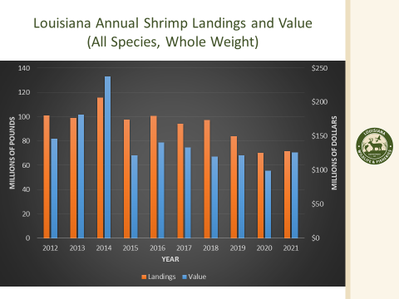
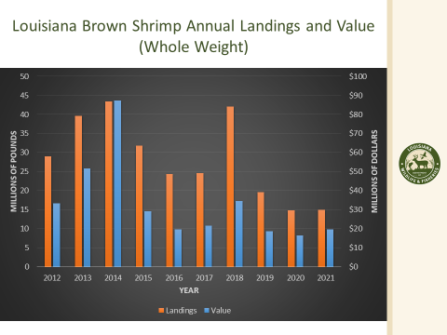
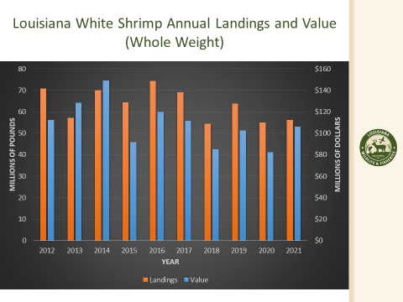
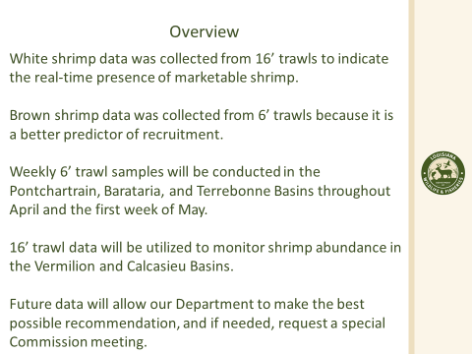
- The board discussed the possibility of opening white shrimp season early on the inside
John Brown stated that he worked with LDWF in the Ride-Along Program in Barataria Bay; would be for an early opening, why wait
Andrew Blanchard state that there could be some marketable white shrimp that the industry could go to the Secretary and ask for an early opening of the white shrimp season but the concern is with how much interference this opening might have with the juvenile brown shrimp
Rocky Decharo from Buras, LA stated that he represents about 120 fishermen from the Buras area in saying no this early opening, for multiple reasons; brown shrimp are moving in, the damage done to the brown shrimp if you open early might not be recoverable, fishermen can barely make their bills now, opening five days early will destroy half of our fleets, also a lot of processors are not open right now; concern for average price as well
Acy Cooper asked if recruitment has improved?
Peyton Cagle stated that they started weekly samples in the beginning of April, two weeks ago sampled in Zone 2 and from the first week to last week’s samples we did see a significant increase in brown shrimp recruitment in 6ft trawls
Randy Pearce stated that his opinion if to let shrimp grow and increase the price, so much caught and don’t want to hurt the brown shrimp, a later opening will help everyone
John Brown stated that the shrimp in Barataria zone are not going to get any bigger on the inside because they do not leave
Andrew Blanchard stated to go with the biology
Barry Rogers stated that he is from zone 2 and is against white shrimp opening due to the damage to brown shrimp
Bob Samanie, Lafitte Frozen Foods, stated to follow the science first, the science will tell you what to do
James stated that there is not enough notice for these types of openings and would also ask that the board consider the timing of the opening
Thomas Olander stated that he is not so much in favor of a five day opening or an emergency opening but the Vermillion area is a unique area, dealing with the Calumet Spillway that is inundating the area with fresh water, we do have some shrimp in our bay right now from Sycamore point going West, already lost the east and southeast side of Vermillion Bay already due to the spillway.
Dean Blanchard stated that there needs to be a study on the harm to larvae; no study has been done; not for opening will make less money; leave it closed until the brown shrimp are ready
Angela Portier stated that she is totally against inshore opening
Alan Gibson motioned that the task force recommend not having an early opening of white shrimp season due the data that was presented and the recruitment of brown shrimp in the area, 2nd by Chalin Delaune. Motion carries with roll call vote, 1 no- Rodney Olander and 1 abstained- Acy Cooper.
Andrew Blanchard stated that the LDWF Commission meets in 14 days, if the data supports it, the season could open as early as May 10 but it will al depend on what the data says, recommended that shrimpers attend the Commission meeting to provide feedback
- Jack Isaacs provided a presentation on imports of frozen shell on shrimp by size category
SHRIMP PRODUCT IMPORTS IN 2021
Shrimp-Based Food Items produced in another country and
shipped and sold to organizations in the United States
Shrimp Product Imports 2021
Pounds | Value
1,971,440,495 | $8,013,566,964

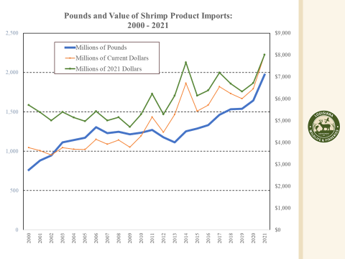
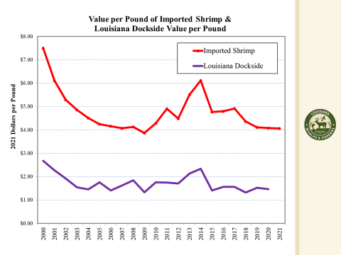
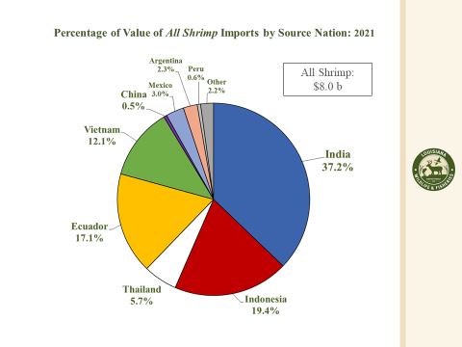
Board expressed concern with imports
Discussed the Governor’s designee participation in meetings, the industry as a whole needs to be more proactive in reaching out to their local delegation
- The board discussed the shrimp sunset review
Andrew Blanchard stated that the tariffs on shrimp coming into the US is reviewed every five years, would like to look into supporting the funding of the sunset review to keep the tariff in place; will need to look into the legality of this and if it is possible. Board plans to take this item up at a future meeting for further discussion once they have more information
- Acy Cooper led discussion on TEDs and debris in Grand Isle
Requesting that LDWF draft a letter to NOAA to see what can be done about TEDs, there is a lot of debris in Grand Isle from the hurricanes that has not been cleaning up and it is causing issues with TEDs. Peyton Cagle stated that he will run this request up the chain at LDWF but will need some evidence of this (photos, etc.) proof that debris is blocking TEDs.
Dean Blanchard asked that an item be added to the next meeting agenda to discuss seafood country of origin labeling and checking that this new regulation is being followed
- The task force heard and update on the 2019 Fisheries Disaster Funding
Peyton Cagle stated that the first round of review comments were received by NOAA and sent back to LDWF for a response
- The board opened up the floor for election of officers
Chalin Delaune motioned to nominate Acy Cooper as the STF chairman, 2nd by Rodney Olander. Motion carries.
Alan Gibson motioned to nominate Rodney Olander as the vice-chairman of the STF, 2nd by Acy Cooper. Motion carries.
VIII. Public Comment:
Barry Rogers requested that the last week of sampling for the ride-along program be set closer to the LDWF Commission meeting; Peyton Cagle stated that he would be against this due to scheduling/timing and the possibility of weather events
IX. The next STF meeting was scheduled previously for Wednesday, May 4, 2022 for 1pm via webinar. The task force set their next in-person meeting for Wednesday, August 3, 2022 for 10am at the Terrebonne Parish Main Library
X. Rodney Olander motioned to adjourn, 2nd by Acy Cooper. Motion carries.

